1. What is software? What is software engineering?

* Software is a set of instructions, data or programs which are used to operate a computer and execute specific tasks. In simple form it tells the computer what to do.
* Software engineering is a branch of computer science. It usually deals with testing, maintenance of software, development and designing. Software engineer builds programming languages to develop software solutions.

2. Explain types of software.

* There are mainly two types of software 1) Application software 2) System Sofware.
* Types of Application software: MS word, photoshop which is used in general purpose.
* Types of System software: Linux, windows etc. (operating system), interpreter, compiler.

3. What is SDLC? Explain each phase of SDLC.

* SDLC stands for Sofware Development Life cycle.
* It is a structured process used to develop, design and test good quality software.
* This model outlines a plan for each stage of software development which ensure to perform tasks efficiently and delivers software at low cost within the given timeframe.
* There are mainly 6 stages of SDLC.
  1. PLANNING
  2. DEFINING
  3. DESIGN
  4. DEVELOPMENT
  5. TESTING
  6. DEPLOYMENT AND TESTING.

4. What is DFD? Create a DFD diagram on Flipkart.

* DFD stands for Data flow diagram. It represents the flow of data within an information system.
* In simple form it is a graphical representation which can be understood by both technical-nontechnical users.
  1. Zero-level and First level diagram

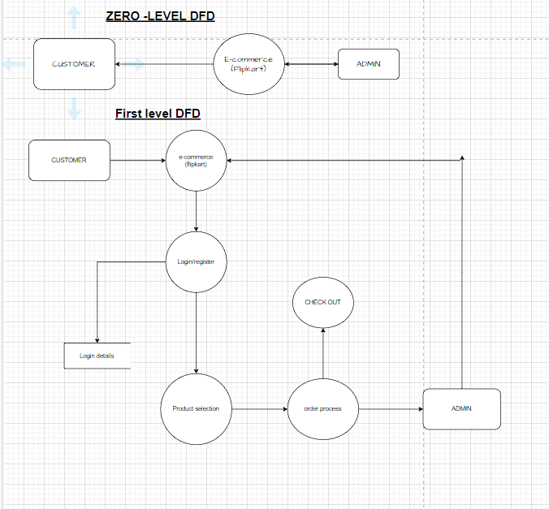

2. Level 2 DFD Diagram (Flipkart).

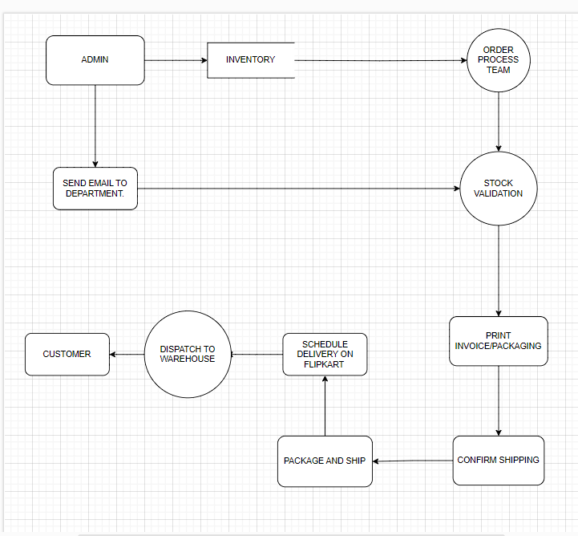

5. What is Flow chart? Create a flowchart to make addition of two numbers.

* A flowchart is a diagram that depicts a process, system or computer algorithm. They are widely used in multiple fields to document, study, plan, improve and communicate often complex processes in clear, easy-to-understand diagrams.
* It is described in various shapes, Such as Rectangles, Ovals, Diamonds and many other shapes.

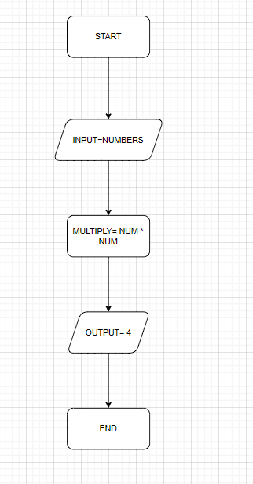

6. What is a Use case Diagram? Create a use-case on bill payment on Paytm.

* A use case diagram describes the relationship between user and use cases.
* It is usually a high-level user activity in the system.
* Use case diagram consist of at least two components
  1. An actor.
  2. A use case.

